Engineer Quantify Manual

Contents

**About the recorder** 5

**How do we record** 6

Recording Methods 6

TDM Recording 6

Active VoIP Recording 7

How recordings are stored 8

File Based Recording 8

Frame Based Recording 9

**Recorder Architecture** 11

Recording process 12

Call Archiving process 12

Local archiving 12

Network archiving 12

Search process 13

Playback process 13

Replay to browser 13

Replay to 'phone 13

**Recorder installation** 14

**Hardware** 15

Server – Front. 15

Server – Rear. 16

Server – Internal Components. 17

Dongle connection 19

Single Board Computer 20

Line Cards 21

**Network Storage and Archiving** 22

**No table of contents entries found.** Overview 22

How it works 22

Replay 22

Backup 23

Disaster recovery 23

**How to shut down the recorder** 24

Method One, Standard shutdown procedure. 24

Method two, Engineer level shutdown procedure. 27

**Recorder service** 33

Running as an application. 33

Running as a service. 33

The recorder continually reboots after powering on. 35

The recorder shuts down as soon as a user logs on to the server operating system. 37

**How to install a license** 39

How to apply a license 40

How to check a time limited license. 42

**How to apply a patch, or upgrade the recorder**. 44

**Connecting Extensions** 49

Aastra 49

TDM 49

**Replay** 50

Replay to browser 50

Replay to 'phone 50

Network Archive 51

**About the recorder**

The Red Box Recorders Quantify recording platform utilises the very latest software techniques to provide high performance simultaneous record and replay. Local and remote access is provided through a user friendly WEB based interface (BUI), allowing quick and easy retrieval of every recording.

* Call Handling Interaction analysis to improve business process and training
* Regulation and compliance for communication within the financial sector
* Public Safety mission critical recording for emergency services, transportation and air traffic control
* Specialist security monitoring and surveillance in government and military market

Within the same recording COTS server chassis, the Enterprise wide voice recorder will record TDM, IPT, Digital extensions, Analogue channels, SIP and H323 as well as multi technologies; Cisco, Nortel, Avaya, Alcatel, Mitel, Siemens, BT, IPC, Etrali, Motorola etc. It can record 240 channels of digital or analogue extensions / 480 E1 channels / 500 channels of VoIP in a true single server solution. The Quantify recording solution offers powerful plug and play, single box solution to VoIP and conventional telephony recording with optimal connectivity.

Quantify uses an embedded database within its architecture. This database is not exposed to the users of the system at all, and requires no administration or management, simply put the database is in place to store and track call related information, optimising performance and minimising overheads on the system or its administrators. The database is adaptive and supports unlimited backwards compatibility, so the solution can deliver customised integrations without impact to support or compatibility with new features or functionality.

This database has several unique benefits to the customer:

* No administration, licensing, or maintenance.
* All data CTI, Call data and audio records are stored within the core database securely. In addition to this, all META data is permanently stored with the audio for replay, meaning full replay against any data item from any replay media (online, DVD, TAPE, NAS etc.)
* No additional databases to install, support, manage, backup or synchronise – the one database manages it all.
* No additional database servers – the recorders database is on the recorder, and no additional servers are needed – ever. This results in a small installation footprint reducing cost, heat, power and maintenance overhead.
* Fully resilient, the database is made up from data stored as part of the audio recordings and can be reconstructed at any time automatically by the system from any set of stored voice recordings. This enables damaged systems to be restored or backup calls to be replayed by any authorised system.
* Fast access and no restrictions on the volume of data recorded or stored with a call. The database has been tested to many peta bites.
* No licensing issues – no hassle with licensing or documentation as an embedded component of the recorder this has no overhead for IT to manage.
* Simplicity – the solution delivers a simple architecture that delivers advanced functionality with leading edge technology in a package that keeps the system easy to use, administer and support.

**How do we record**

Recording Methods

Within the same recording server chassis, the Enterprise wide Red Box voice recorder will record TDM, IPT, Digital extensions, Analogue channels, SIP and H323. It can record 240 channels of digital or analogue extensions / 480 E1 channels / 1000 channels of VoIP in a true single server solution.

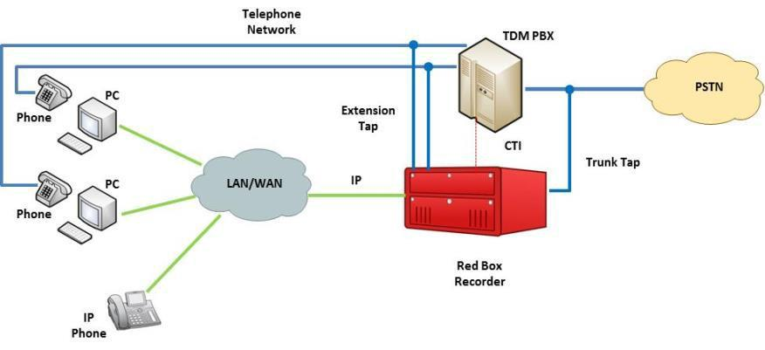

TDM Recording

Red Box Recorders uses AI Logix cards to integrate with analogue and Digital Extensions and Trunks. AI Logix is the largest manufacturer of recording cards in the world. Analogue, Digital and IP recording can be mixed in the same server. In fact, the recorder can manage any mixture of recording inputs (up to 1000 per server), with unlimited recording capacity utilising multiple recording servers.

Active VoIP Recording

Active recording involves sending a replica of captured audio from a gateway, conference bridge or IP-phone to the recording system using standard network routing. Red Box Recorders integrate with a number of Contact Centre solutions in order to facilitate Active VoIP recording. Red Box is currently certified from Avaya, Mitel and

Alcatel for call conferencing on their latest Media Server releases. Active VoIP solutions offer a number of advantages over Passive VoIP recording solutions especially in complex or spatially dispersed networks. Active VoIP recording relies on another component sending a duplicate copy of the audio to the recorder from a Media Server. Because the Media Server is sending the VoIP audio to the recorder it is generally able to send audio for a range of TDM and IP devices. Whilst Passive VoIP recording solutions are reliant upon the data which is presented to them, Active VoIP solutions can record all calls centrally within a Data Centre or Hosted Environment without requiring additional network configuration. Of course, it is important to take into account the additional bandwidth required for the Call Conferencing.



**How recordings are stored**

There are two types of recording engines available with recording systems: File Base and Frame Based. Red Box use a Frame Based recording system as it is proven to be more efficient, scalable and secure compared to file based recording engines. Here is an overview of each method:

File Based Recording

The architecture of a traditional recording system is file based where a new file is opened at the start of each call. This means that large systems may contain hundreds of open files leading to high rates of HDD access and fragmentation of HDD utilisation, causing reduced performance and in worse case scenario’s, to fall over completely.

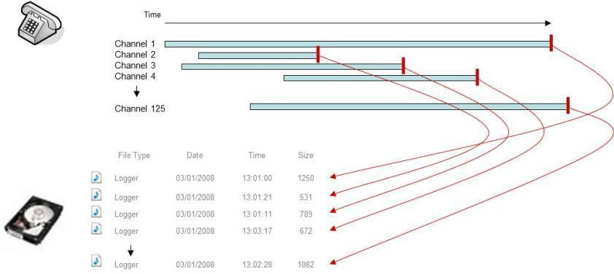

There are also significant security issues with traditional recording solutions in that the standard FIFO process means files that have been deleted to comply with data protection rules may still be recoverable until overwritten. Any power loss will also mean the loss of all open files.

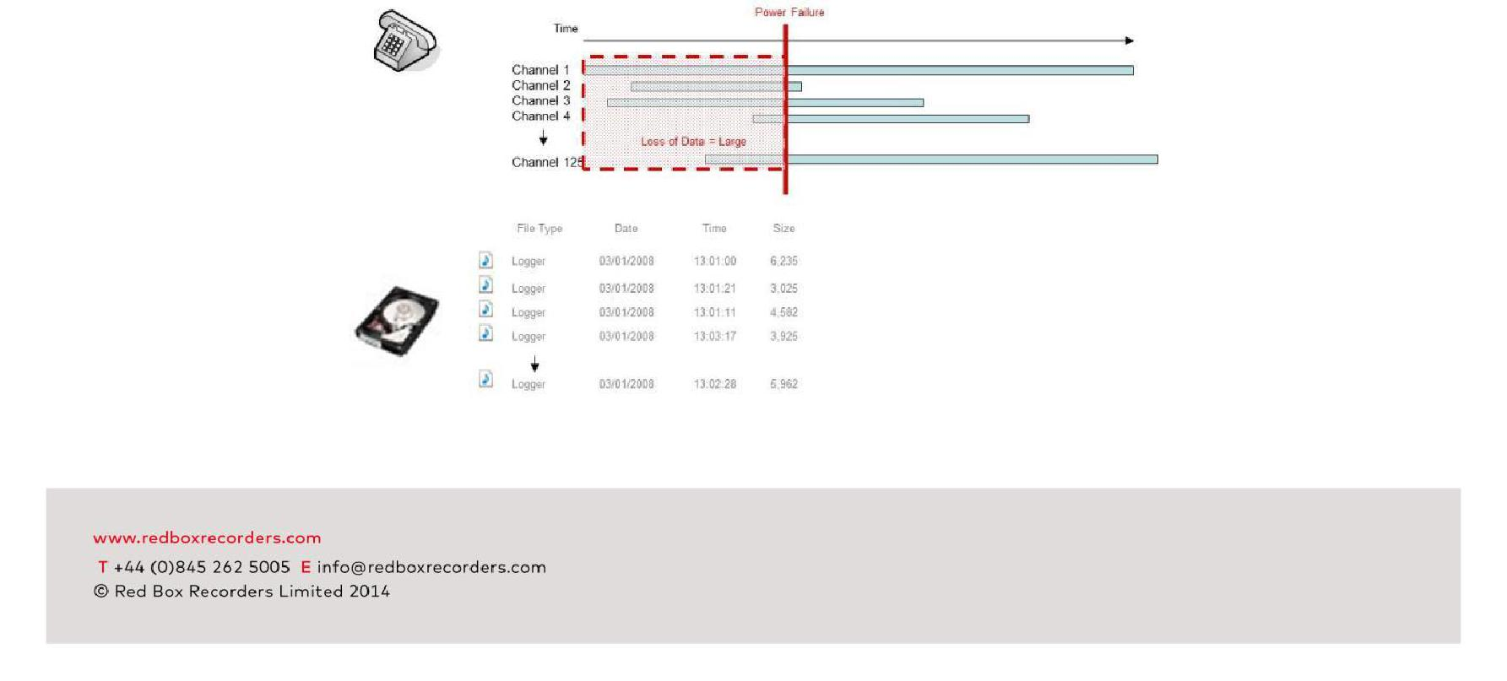

*Traditional recording consequences of power loss*

A standard voice recorder only ever stores basic information and relies on an external database for additional customer/system data.

The recorder archives also need a separate database so recovery and disaster recovery require the maintenance of both systems. Administration and maintenance become complex tasks. Traditional recording systems tend to require a multiple server infrastructure even for basic configurations.

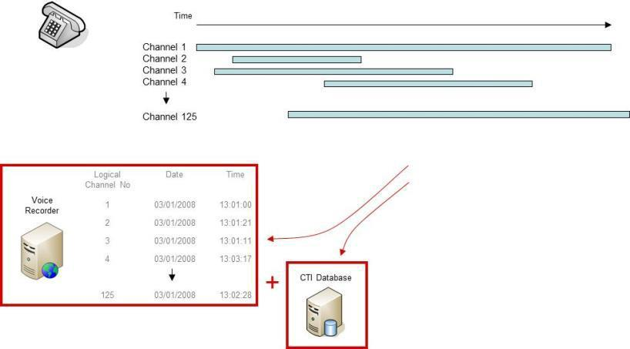

*Traditional recording multiple server requirements*

Frame Based Recording

On the other hand the architecture of a frame based system consists of a specifically designed recording engine which opens a single file across all active channels in the system. This results in very low HDD access even on large systems and no fragmentation of the HDD.

Due to the obfuscation of files within the frame based recording structure, all calls are effectively encrypted as soon as they are recorded and for security purposes when frame information is deleted files are unrecoverable

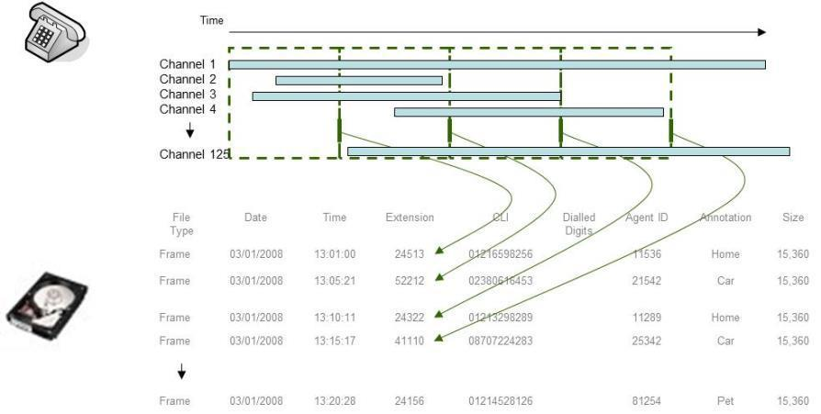

*Frame based recording method*

The use of Red Box frame based recording technology means that any type of data can be processed by the recording engine with unlimited throughput and exceptional capacity. Specifically designed to cope with IP radio data (with massive throughput and intensity) the system delivers several other unique benefits.

Because each frame is only open for a few seconds at any time, the system is very resilient to power outage with respect to losing or corrupting data. Any system will normally lose the file that is open when power is disconnected, and on other recording systems that could be 30 minutes of conversation over many channels, resulting in many hours of data loss. With the Red Box Recorders system, only the currently open frame file (seconds of audio across the system) will be lost, with all but the last few seconds of all conversations being retrievable up to the point of power outage.

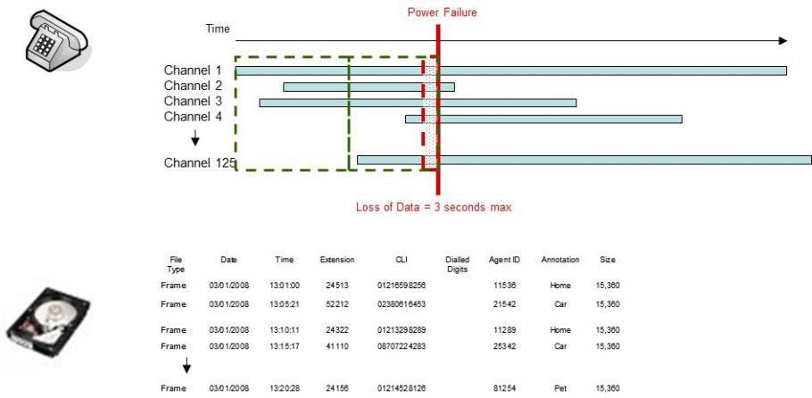The system utilises the same system for archiving of recordings. This again has several benefits. Because the frames of data are all referenced, cross referenced and embedded with all associated data, all on-line, near-line or off-line recordings contain the same data. This results in a very simple system for users and no overheads for System Managers. Additionally if any data corruption should occur to the stored media, all other data can be recovered, limiting loss of data to the corrupted segments of the media, again generally without the costly process of sending media away for recovery.

*Frame based recording consequences of power loss.*

The voice recorder stores all information, including all CTI & annotated information, thus never requiring an external database server. All archives contain all information and no separate admin system is required.

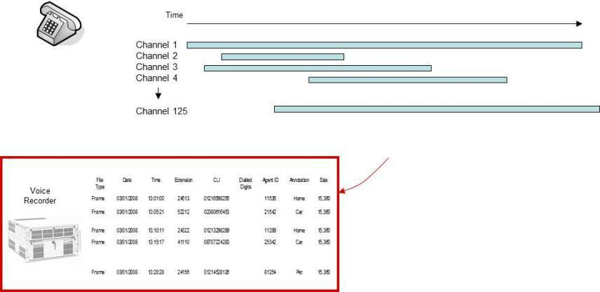

*Frame based recording, single server requirement*

**Recorder Architecture**

The core of the Red Box recorder is a process called LTR. The main function of this process is to simply record and save audio along with the associated call metadata.

Audio being presented to the LTR process has to be in a format that it can decode. To change the audio into a Red Box format, the recorder utilises a protocol processor (PP) which acts as a codec. There is a PP for each type of integration; Mitel, Cisco, Avaya, Aastra etc. The recorder can have to up to 10x PP’s activated on each recorder.

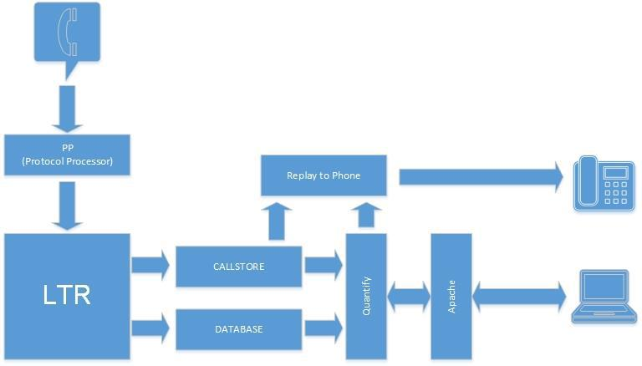

Recording process

The recording process is exactly the same no matter which PP is installed. The only requirements are that the correct PP is installed and the data is being received by the recorder. The basic stages of recording are as follows.

* Audio is sent to the recorder
* The install protocol processors are applied to the data to determine if the audio can be decoded.
* If the PP's are unable to process the data, no recording takes place but the PP will continue to analyse all incoming data for valid audio.
* If the installed PP can process the data, the audio is extracted and saved in to the currently open frame file and saved in the callstore.
* Once the frame file reaches 15MB in size the file is closed and a new frame file is opened.

Call Archiving process

The recorder continually archives calls locally to the callstore. However, it is capable of archiving calls to a network location. This provides a back up of the saved calls and allows access from other recorders or a Red Box media server to historic calls. The format of the network archive is exactly the same as the local callstore. There is a frame file, and an associated database file. The network storage is not a replacement for the callstore and works in conjunction with the callstore.

Local archiving

Locally, all calls and database entries are located in the callstore and local database. The recorder will save the data in the format of a frame file, and will virtually fill the space available to it. At the point of installation, the software will interrogate the space available to it and set the size of both the callstore and the database. This figure is not dynamic, so if a the drive size alters after installation the recorder software will not be aware of any changes and this could lead to recording failure.

* Calls and call data are saved in the frame file format in the callstore and database.
* This will continue until virtually all the available space has been used. Once there is approximately 2GB to 3GB drive space left, the callstore will start to over write the oldest frame file.

Network archiving

* As a frame file is closed and saved in to the recorders callstore, a copy of the frame file and a database file are sent to the network location.
* The local recorder database is updated to show that the file has been archived.

Search process

Users can connect to the recorder using a web interface (BUI) that is hosted locally on the recorder server using an Apache web server. The user will require a valid username and password to access the recorder browser software, along with a number of settings to allow replay.

* The user browses to either the recorder IP address or DNS name (for example HTTP:\\176.154.32.12 or HTTP:\\recorder). The user can then use the inbuilt search tool to define the search parameters for the call or calls they wish to retrieve.
* As the user starts the search, the search criteria is sent to the recorder and a search is conducted using the database entries located in the local database. This database keeps information for both locally archived data (callstore) and data that has been archived on to the customer network (network archive). The search results are returned back to the users browser session.

Playback process

The play back process uses the data returned in the search process to allow the user to select the call to be replayed.

* When the user selects the call to be replayed, the call details are once more sent back to the recorder and the call is extracted from the corresponding frame file or files. These files can be located on the physical recorder (callstore) or on the network (network archive). As far as the end user is concerned the two locations are combined and they are searching just one large database.
* The audio is then reconstituted and sent to the appropriate replay engine.

Replay to browser

The default replay method is to use the Red Box recorder web page. Once a call is selected for replay, an imbedded media player is pushed out to the users browser session allowing replay of the call. The media player has a number of inbuilt functions and features that give the user the ability to control the replay of the call.

Replay to 'phone

If the solution has been provided with a replay to 'phone server, the user has the ability to chose the type of replay used. This is configured on a per user basis through the browser session. If replay to 'phone is selected, instead of the reconstituted audio being sent to the user via the browser session, the audio is sent

to the replay to ' phone server. the replay to 'phone server interrogates the user settings and obtains the dial back number. The process then calls this number and the audio is streamed to the users hand set. They continue to have control of the audio via the web page.

**Recorder installation**

The Red Box recorder is installed on a Windows based server. The software installs a number of files and folders that are critical to operation of the recorder.

|  |  |
| --- | --- |
| File \ Folder | Description |
|  |  |
| C:\LTR | This is the main installation folder and contains the majority of the recorder software and |
|  | configuration files. This has to reside on the C drive of the server. |
|  |  |
| C:\RAM | This folder is used in conjunction with the protocol processors and is critical to the operation |
|  | of the system |
|  |  |
| \Callstore | This folder contains all the locally archived calls in a series of folders (1 to F) and frame files. |
|  | This is a system critical folder and the files contained within cannot be altered manually |
|  | without affect the stability and reliability of the recorder. By default, on a new installation |
|  | where no changes have been made, this resides in the C:\LTR folder. This can be changed |
|  | and moved to the next logical drive on the system. For instance, if a recorder has a C:, D: |
|  | and E : drive it can go on the D drive but not the E drive. This folder has to reside on the |
|  | server and cannot be mapped or network drive. |
|  |  |
| \Database | This folder contains the locally stored database entries for the recorder. This includes all |
|  | references to the local store and the network archive location. This folder will reside on the |
|  | same drive as the callstore. |
|  |  |
| Recorder.INI | This file is located in the C:\Windows folder and contains a large number of system |
|  | configuration items, including the username and password (encrypted) being used to run the |
|  | system as a service. Any alterations to this file will require a system restart. If incorrect |
|  | entries are placed into this file, or it is removed or access restricted, this will affect the |
|  | stability of the recorder. |
|  |  |

Along with the software, each recorder has a physical USB dongle installed. This dongle contains the four digit system ID number used to license the system. No software is contained on the dongle. When installed in a Red Box built system, this dongle is contained inside the recorder so that it cannot be removed by accident. If the drive is removed the recorder will still record however all playback will stop until the dongle is replaced.

**Hardware**

Server – Front.

Red Box recorders are rack mounted servers. Below is the 6U model. The front of the server is accessed by a lockable panel

1. System reset button
2. Hard drive activity LED
3. Hard drive 0
4. Hard drive 1
5. System power switch
6. Keyboard lock
7. Alarm buzzer silence switch
8. Power supply alarm LED

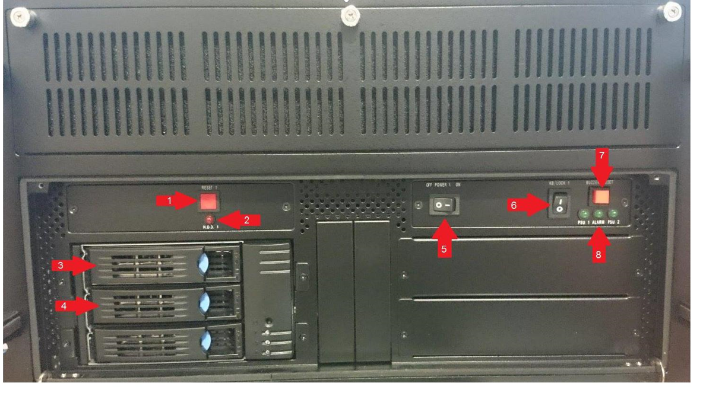

Server – Rear.

All connections are made via the rear of the server.

1. Case Fan
2. Expansion slot
3. USB port
4. Network Cards
5. VGA screen connection
6. Case Fan
7. Case Fan
8. Power supply LED
9. Power supply switch
10. Power supply
11. Power supply mains connector

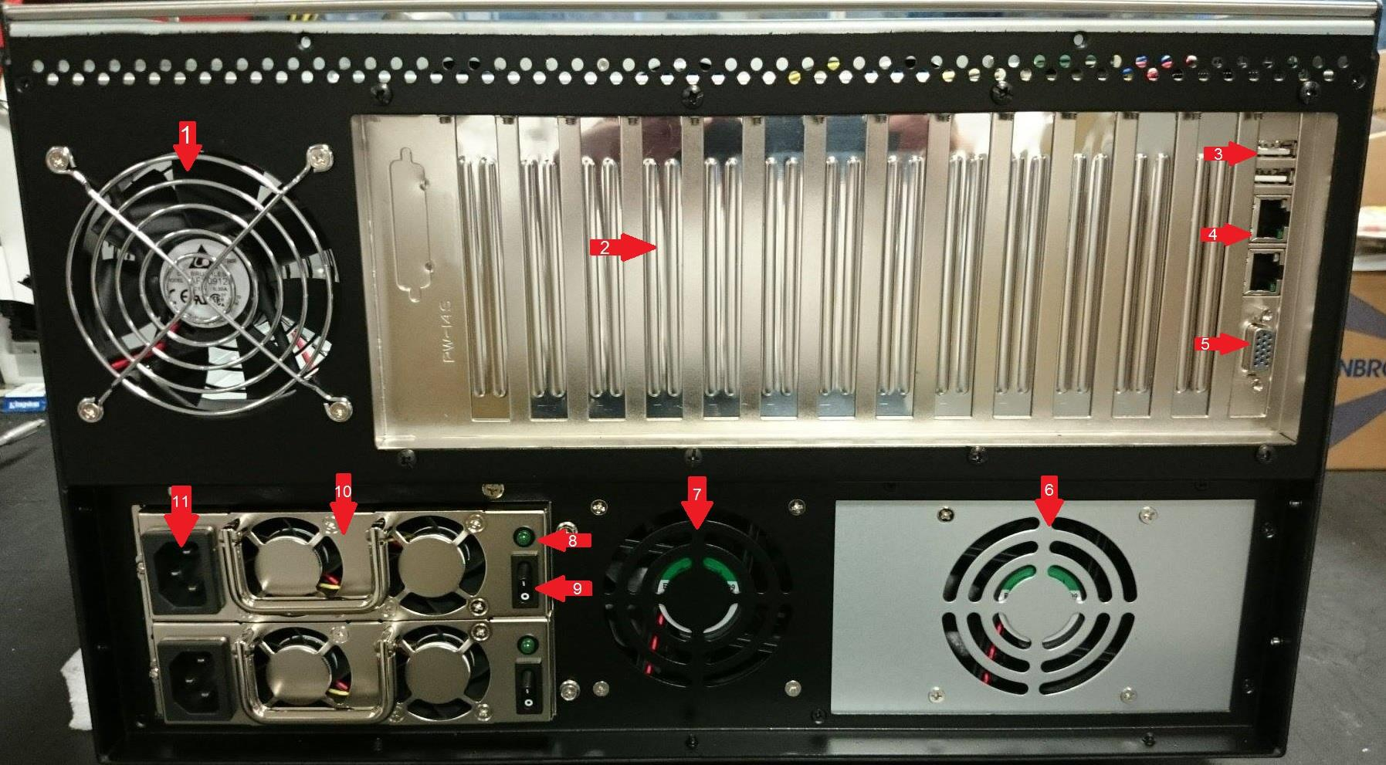

Server – Internal Components.

1. Single board computer (SBC)
2. SBC power connector
3. Serial port connectors
4. SATA connectors
5. Card retention bars
6. Card retention screw (Philips no.1 point)
7. Line Card
8. Line card identification switch
9. SBC/System memory
10. Speaker connection
11. Hard drive LED connection
12. SBC jumper (not to be removed)
13. Rear USB ports

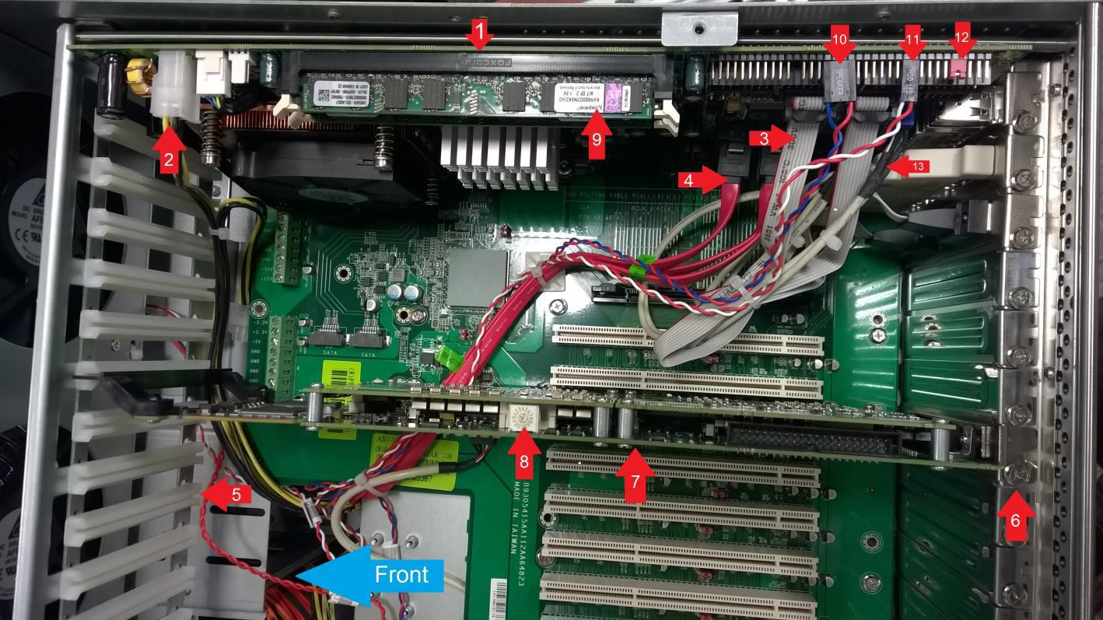

Dongle connection

The Red Box server identifies itself by the use of a system USB dongle. For security reasons, on a Red Box built server, the USB dongle is installed inside the server.

1. Red Box USB Dongle – note retaining cable tie.
2. USB connector used for system dongle
3. Front panel power switch connector
4. Front panel reset switch connector.

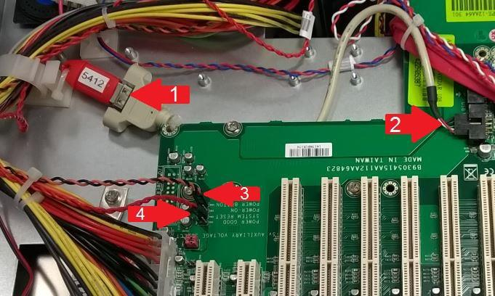

Line Cards

To be able to connect TDM devices to the recorder, a line card is required. Each line card has up to 24x ports or channels. Each card has to be identified on the system by a unique card ID. This is set using the card ID selection switch located on the top of each card.

The card ID is a hexadecimal value (0 to F) and if a line card is replaced would have to be set on the replacement card. Cards are usually installed started at the SBC and, if standing at the rear of the server, and go from right to left.



1. RJ21/Amphenol connector
2. Motherboard connector – Note: the type of connector depends upon the motherboard release.
3. Rear card steady

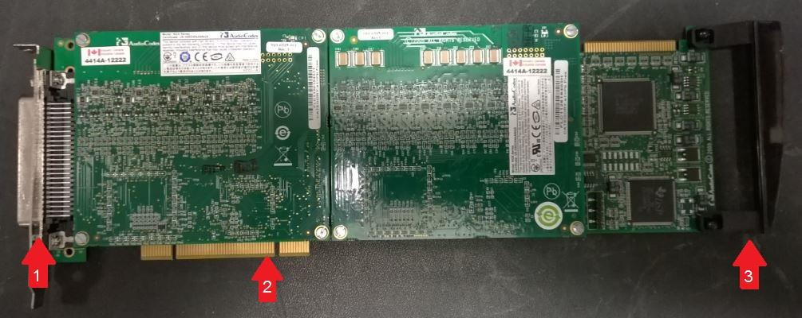

For a line card to be removed, first a retention bar will have to be removed. Care should be given so that the screws holding this bar in place are not dropped behind the SBC. Once the bar has been removed a retaining screw will have to be undone to allow the card to be extracted.

The card is a tight fit in the chassis. Therefore, the card should be removed by holding both the front and the rear of the card and gently rocking the card.

When the replacement card is inserted, make sure the rear of the card is located in the plastic guide. This stops the card from flexing.

**Network Storage and Archiving**

Overview

The recorder can archive its calls to network folders. This Networked Storage feature can be used to increase the capacity of the recorder, act as a backup and perform a disaster recovery function.

How it works

As calls are recorded they are written to files in the recorder. The Networked Storage process writes these files out to a networked storage device either soon after they are written or at a scheduled time (depending on how the recorder is configured by the system administrator). Also written to the networked storage are incremental database files (more on these later). This continues until the networked storage either becomes full or the recorder writes its pre-set allocation (another configuration setting) at which point the recorder deletes the oldest calls and re-uses the space for more recent calls; the behavior can be that it starts to use another networked storage device or new folder on the same device.

Replay

When a call is selected for replay if it is present on the recorder it is replayed from there. If the call has been written to networked storage and is no longer present on the recorder then it is replayed (without recourse to the user) from the networked storage. This means that networked storage acts as an extension to the capacity of the recorder. Using this method, there is no realistic limit to the capacity of the recorder – all that is needed to increase the capacity is to add more networked storage.

Backup

Unless a schedule is configured all calls are copied soon after they have finished recording to the networked storage. In the event of data loss on the recorder all but the very recent calls are preserved on the networked storage.

Disaster recovery

If the recorder suffers data loss, it is possible to rebuild the recorders database by importing data from a networked storage device – this reads the incremental database records and uses them to create database entries for the calls. It is possible to import to one recorder calls that were archived using another recorder so that a standby recorder on a DR site could be used to replay calls recorded on the primary site in the event of loss of the primary sites recorder(s).

**How to shut down the recorder**

There are two potential ways of shutting down the recorder. These are the normal day to day method, and an engineer level method that should only be used if the recorder is unresponsive or requires additional involvement. Usually, the first method should always be used, unless directed by Red Box.

Method One, Standard shutdown procedure.

This section describes the procedures used for shutting down and restarting the Redbox recorder in a controlled manner.



***The Redbox recorder has to be shutdown or restarted using the Redbox web interface. Shutting down the recorder using any other method could result in loss or corruption of data. This guide is written for a recorder running Quantify 3A. All screen shots are taken from a 3A system. However, the procedure can be used on all Quantify versions prior to 3, but the screens seen by the user may be different from those depicted.***

*If in any doubt, contact Redbox recorders prior to commencing work.*

1. *Browse to the recorder web page.*

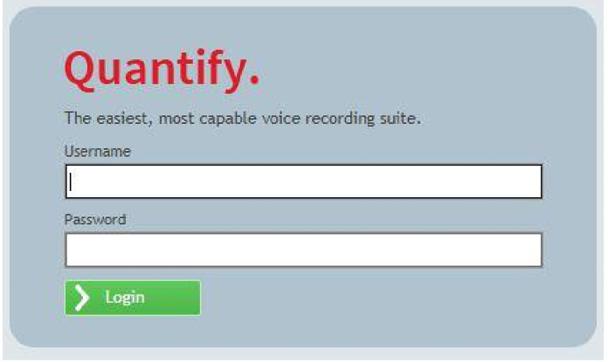

1. Log on to the recorder with an admin username and password that has access to the configuration section of the recorder
2. Locate, at the top of the screen, the section selection icon



1. This will expand the selection window. Select the configuration icon



1. This will open the configuration section of the recorder and a number of icons will be displayed across the top of the Redbox window. Select the maintenance tab.
2. Locate and select the Recorder (Maintenance) icon

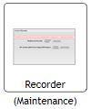

1. This opens the recorder control page. Select either Shutdown or restart. Then select Stop Recorder

 ***The restart option will shutdown the recorder process and then restart the Windows operating system. Once Windows has restarted, if the system is configured to run as a service, the recorder will automatically restart***

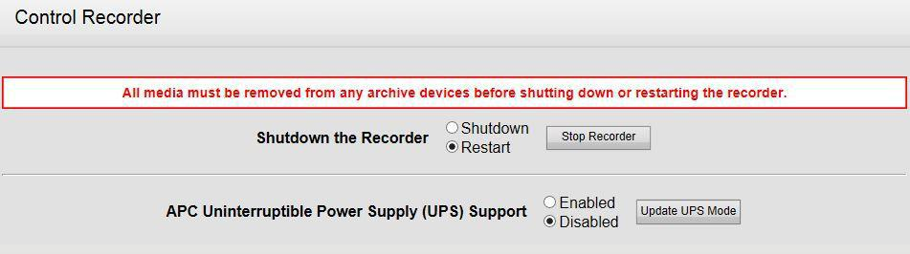

1. Once the shutdown button is pressed a warning is displayed. Select OK to shutdown or restart the recorder

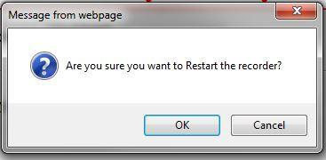

The recorder will now start the shutdown process.

 ***At this point all recording and playback will stop. Recording and playback will not be possible until the operating system and the recorder have restarted.***

1. The recorder will shut down, then Windows will restart. Once Windows has restarted, and the recorder process has been restarted, browse to the recorder web page and log on to confirm that the recorder is back on line and recording.

Method two, Engineer level shutdown procedure.

This Section describes the procedures used for shutting down and restarting the Redbox recorder in a controlled manner at an engineer level. This is different to the standard shutdown procedure, as it involves altering some of the system files to only allow the Redbox recorder software to shut down in a controlled manner, whilst leaving the operating system up and running.



***The Redbox recorder has to be shut down or restarted using the Redbox web interface. Shutting down the recorder using any other method could result in loss or corruption of data. This guide is written for a recorder running Quantify 3A. All screen shots are taken from a 3A system. However, the procedure can be used on all Quantify versions prior to 3, but the screens seen by the user may be different from those depicted.***



***This procedure has to be completed by a competent technician.***

*If in any doubt, contact Redbox recorders prior to commencing work.*

1. Log on to the recorder server.
2. Locate and edit the following file

**C:\Windows\RECORDER.INI**

3. Under the heading [General] enter the line ShutDownOS=1 as in the example below

**[General]**

**ShutdownOS=1**

4. Save and close the RECORDER.INI

1. Browse to the recorder web page.

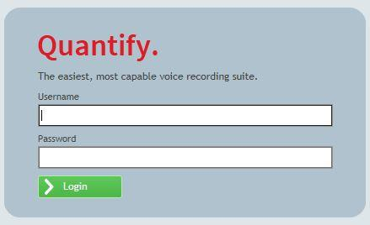

1. Log on to the recorder with an admin username and password that has access to the configuration section of the recorder
2. Locate, at the top of the screen, the section selection icon



1. This will expand the selection window. Select the configuration icon



1. This will open the configuration section of the recorder and a number of icons will be displayed across the top of the Redbox window. Select the STATUS tab.



1. Locate and select the Recorder Status Icon

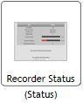

1. This opens the recorder status page. If the RECORDER.INI modifications have been successful, a statement is displayed on the screen stating

***Restart of the Operating system disabled for diagnostic purposes. Operating system restart should be re-enabled for correct recorder operation.***

1. If the above statement is not displayed after 5 minutes, the RECORDER.INI alterations are not in place. Check that the settings are in place and that they are correct. Failure to enter the correct line in to the file will cause the recorder to physically shutdown.
2. From the row of icons across the top of the page, locate and select the maintenance tab
3. Locate and select the Recorder (Maintenance) icon



15. This opens the recorder control page. Select Shutdown. Then select Stop Recorder

 ***The restart option will shut down the recorder process and not restart the Windows operating system. Once Windows has restarted, if the system is configured to run as a service, the recorder will automatically restart.***

***If the record.ini is not modified correctly prior to the recorder shutdown command being entered, the recorder process will end and shutdown the operating system. A manual power on of the servers operating system will be required to restart the recorder.***



1. Once the shutdown button is pressed a warning is displayed. Select OK to shut down the recorder.



17. The recorder will now start the shutdown process.

 ***At this point all recording and playback will stop. Recording and playback will not be possible until the operating system and the recorder have restarted.***

1. The recorder will shut down.
2. To check that the recorder is offline, open the windows task manager and locate the Process tab.
3. The recorder process is called LTR.EXE. IF this is still displayed, as below, the recorder is still running. If it cannot be located, then the recorder is now offline.

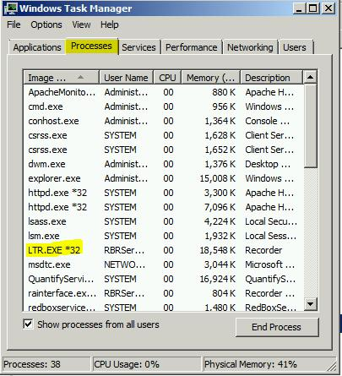

 ***At this point, changes can now be made to the recorder. Once these changes have been made, the operating system can be restarted using the normal Windows restart button.***

1. When the operating system has restarted, the recorder should automatically start. To check that the recorder is online, open the task manager and locate LTR.EXE. If it is present log on to the recorder web page. If the recorder is up and running as designed, the search and replay page will be displayed.
2. The changes made to **C:\WINDOWS\RECORDER.INI** must now be reverted. Edit the file and remove the **ShutDownOS=1** line. Save and close the file.
3. The recorder will not require to be put back in to the resilient mode.



**Recorder service**

The Redbox recorder can either run as an application or as a service. When the software is first installed, the recorder runs as an application. The basic procedure is outlined below. If the recorder is not configured correctly the application will not run as a service. Equally, if the account being used to run the service does not have the correct privileges this can affect the way the recorder works and make the system unstable.

Running as an application.

* The recorder software will not start when the operating system starts.
* The recorder only starts when a user logs on to the operating system.
* The recorder stops when all users log out of the operating system.

Running as a service.

* The recorder software will automatically start as soon as the operating system is online.
* If the recorder is restarted, the Redbox service account will automatically restart recording without a user logging on to the operating system.

 ***Warning! If the recorder is not set to run as a service, it will only start when a user logs on to the recorders operating system. The recorder process will shut down and the recorder will stop recording if that user subsequently logs off the operating system.***

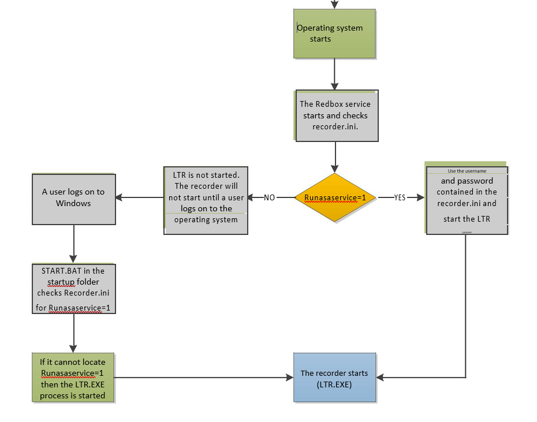



The recorder continually reboots after powering on.

For the recorder to work as designed, the service account has to have full read and write access to the following files and folders

* C:\LTR
* C:\RAM
* C:\WINDOWS\RECORDER.INI

• C:\LTR\CALLSTORE (this is the default location, however this can be moved)

If the process does not have full access to these folders then the recorder service will attempt to start the LTR process and it will fail. When LTR fails, the recorder watchdog will detect the failure and automatically restart the operating system. The recorder will then continue to restart and repeat the process.

To be able to bring the recorder up the server must be started in safe mode and recorder.ini opened for editing. Recorder.ini is located in the Windows directory. The following lines have to be altered

* Runasaservice=1 needs to be set to Runasaservice=0
* Delete the username
* Delete the password
* Restart the recorder

 ***This does not rectify the permissions issue, it only allows the recorder to be started, and run as an application***

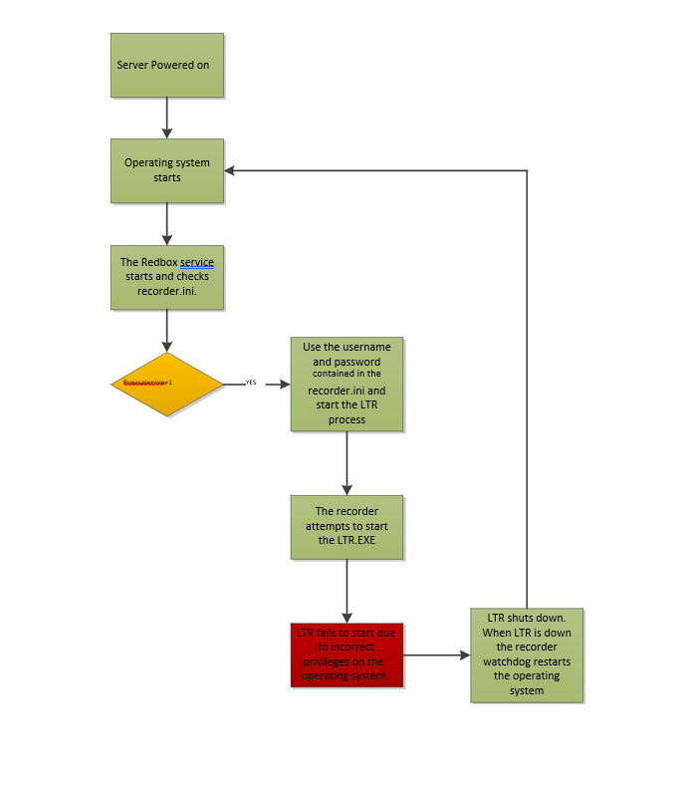

The recorder shuts down as soon as a user logs on to the server operating system.

In this instance the recorder is set to run as a service, and the recorder runs as designed until a user logs onto the recorders operating system. When the user logs on, the start.bat file is run from the startup menu. However, when the security permissions are set that the user does not have high enough privileges to allow the batch file to access C:\WINDOWS\RECORDER.INI then the start.bat process is unable to determine that the recorder is running as a service.

When it cannot detect that it is running as a service it will start a second instance of LTR.EXE. This process cannot exist twice on the same server, therefore, when the second instance starts both processes fail and the operating system will shut down.

This can be resolved by deleting the start.bat file out of the start menu.

 ***This is not a fix as the issue is caused by user permissions on the customer network. This is a work around. Due to the restrictions, other problems may be encountered. Removing the start.bat file will simply allow the recorder to start and run as designed until the permissions issue is rectified***

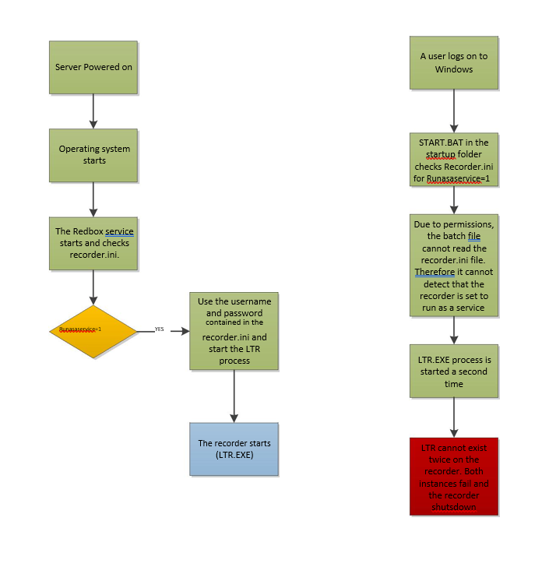

**How to install a license**

This section explains the process used to apply a system license and how to check, and update the time limited licenses.

This document is pertinent to Quantify version 3B and above. However, this process can be used on previous releases of the Red Box software but the icons used in this document may be different from those seen on older releases of software.

 ***New recorder installations will be issued with a time limited license. This license will have to be updated prior to the date it is set to expire. If the time limited license expires prior to the full or updated license being applied, the recorder will stop recording.***

This guide assumes the recorder has been installed and is ready for configuration and licensing.

If in doubt, contact Red Box

How to apply a license

Before commencing, you should have the license file supplied by Red Box recorders or by the authorised Red Box supplier. The license codes contained in this document are for information only and are not relevant to any recorder installation.

1. Log on to the recorder using a username and password that has access to the system configuration section.



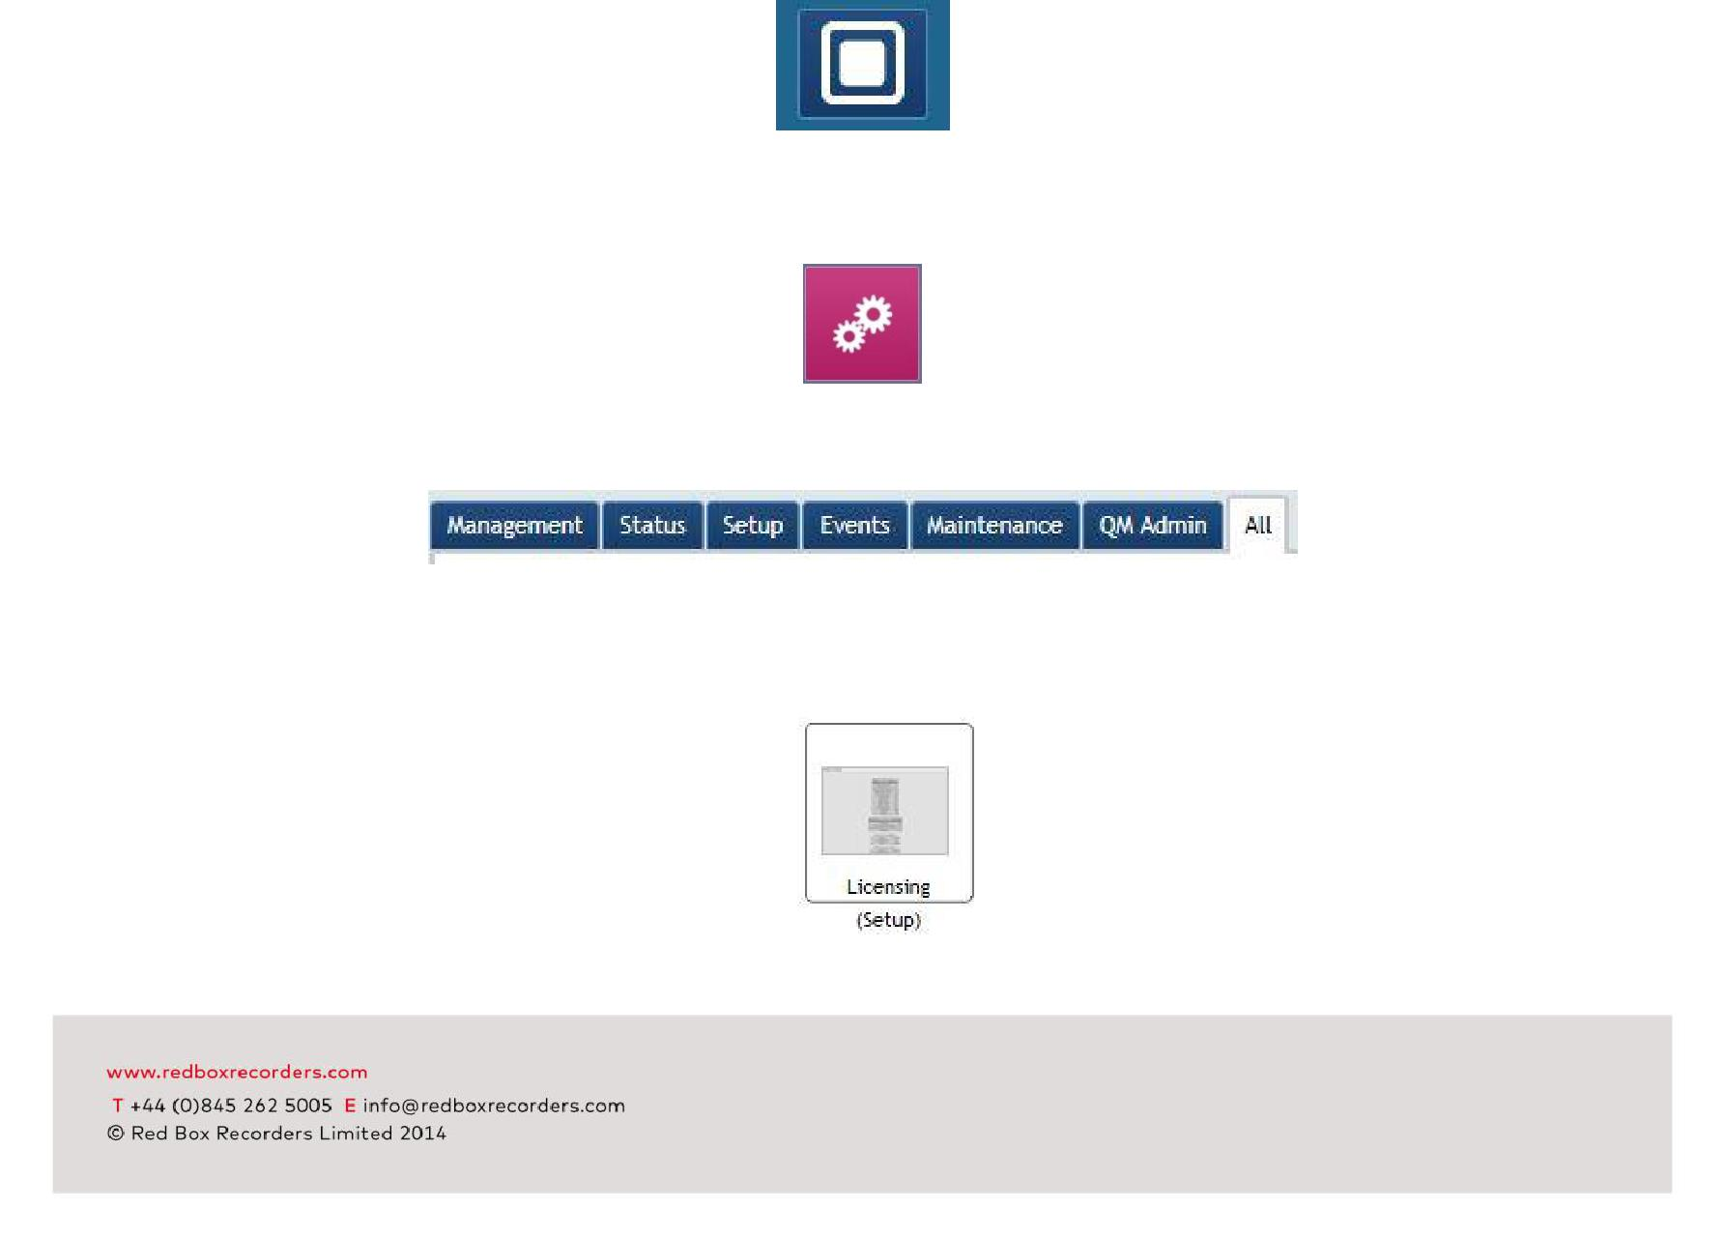

1. Locate the navigation button at the top of the screen
2. Navigate to the configuration section. *If the icon shown below is not visible, the account used to log on* *to the recorder does not have the correct permissions.*
3. Once in the config. Section locate and select the SETUP tab
4. Locate and select the LICENSING icon
5. This opens the licensing page. From this page, the user can see what the recorder is currently licensed for.
6. Locate the license code entry box at the bottom of the page

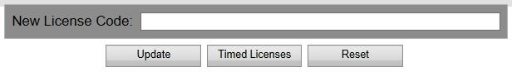

1. Enter the new license code in to the box

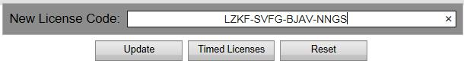

1. Select UPDATE.
2. If there was an issue with the license code the message below will be displayed. If this is the case, re-enter the code and update once more. If the license code entered fails after a number of attempts, please contact Red Box or your authorised Red Box supplier to check the license code.



1. If the license code is accepted, check the license page to confirm that the elements or features have been added.

***The majority of licenses do not require a reboot after application to activate. However, if a license is applied that will require a full system reboot then the following message will be displayed.***

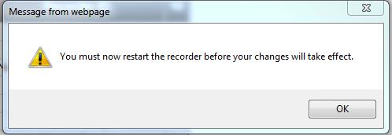

To reboot the system please see the section in this document How to reboot the recorder.

How to check a time limited license.

 ***In certain instances a recorder may have time limited licenses installed. These are not installed on all systems and the following section only refers to systems where they have been used.***

1. Log on to the recorder using a username and password that has access to the system configuration section.
2. Locate the navigation button at the top of the screen



1. Navigate to the configuration section. *If the icon shown below is not visible, the account used to log on* *to the recorder does not have the correct permissions.*



1. Once in the config. Section locate and select the SETUP tab
2. Locate and select the LICENSING icon

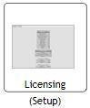

1. This opens the licensing page. From this page, the user can see what the recorder is currently licensed for.

Navigate to the bottom of the page, locate and select the Timed licenses button



This displays any timed licenses currently installed on the recorder.

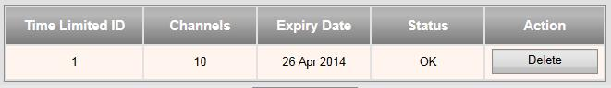

1. If the timed license is due to expire, the license will be highlighted in yellow and the status will display Nearly Expired. A full or updated license will require to be applied before the expiration date to continue recording.

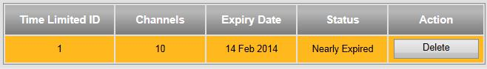

1. If the timed license has expired, the license will be highlighted in red and the status will display Expired. If the recorder has not had a full or updated license applied, the recorder may not be recording. If the recording license has expired and the license has not been updated, a full license must be obtained and applied before the recorder resumes recording. If in any doubt, please contact red Box recorders or your authorised Red Box supplier.

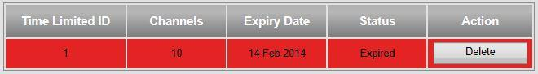

**How to apply a patch, or upgrade the recorder**.

***Prior to installation the correct Redbox update file must be obtained.***

***These instructions are pertinent to Redbox Quantify versions.***

 ***If you do not have the correct update file, please contact Redbox prior to installation. This section assumes a good working knowledge of the recorder, the ability to apply Redbox updates and to be able to locate and modify files on the recorder.***

***It is strongly advised that prior to the work commencing a system configuration file and a system diagnostic file are created.***

 ***The screenshots used in this guide show an upgrade to version 3A build 164. These instructions will work for other release versions of the recorder.***

If in any doubt, contact Red Box prior to installation.

1. Log on to the recorder with a user that has administrator rights and navigate to the configuration section.



1. From the tab menu select ALL
2. Navigate to Software

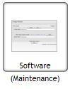

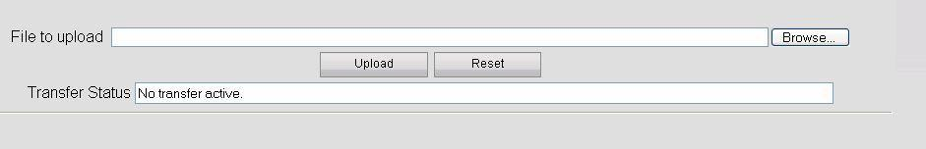4. Select browse.

5. From the dialogue box, navigate to and select the file to be uploaded to the recorder.

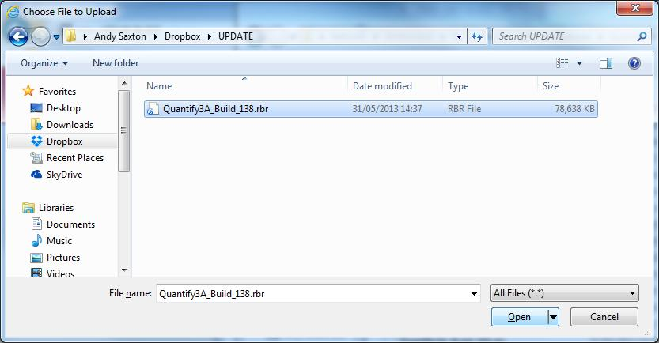

1. When the correct file is located, select OPEN
2. This will revert back to the loader screen, select UPLOAD



1. UPLOAD the file.
2. A message will be displayed asking if you wish to upload the file. Select OK

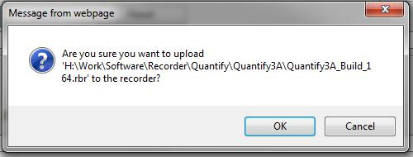

1. The file will now upload and once complete the following will be displayed



1. Once the file has been uploaded, make sure the file is displayed in the pull down box and select

PREPARE.

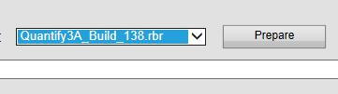

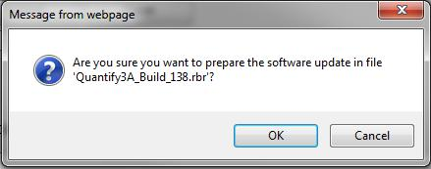12. The following message will be displayed. Select OK to continue

1. Once the file has been prepared the release notes will be displayed. Scroll down to the bottom of the screen and select update

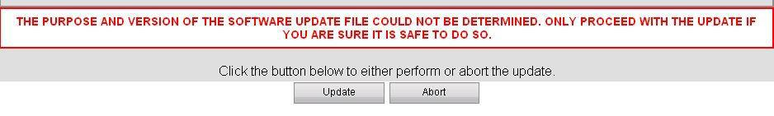 ***This can take a while and is dependent upon the size of the update being applied and the speed of the recorder.***

14. The recorder will now reboot.

 ***At this point the recorder is offline and not recording. It will not record extensions until the update process is complete.***

15. After the recorder logs back on a command window may be displayed.

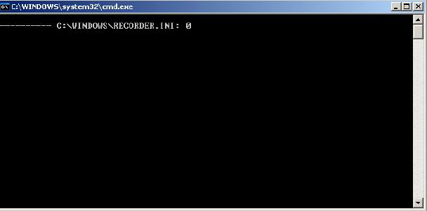

16.  **DO NOT CLOSE THIS WINDOW**.If this window is closed before the final process havebeen allowed to run the installation will fail.

17. The command window may display a number of errors. These can be ignored.

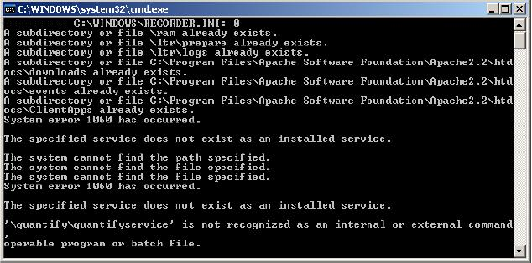

1. Once the installation processes have completed the command box will close automatically.
2. The RBR update has now been applied.

**Connecting Extensions**

TDM

For traditional, or TDM, devices to be recorded first they have to be physically connected to the recorder. This is achieved by the use of a pre-terminated cable that connects the line card installed in the recorder to the customers termination frame. This can use either a Krone IDC connection or a RJ45 connection.

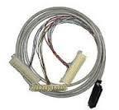

The connection method is a passive connection and is either double jumpered or connected in parallel to the extension on the frame. This connection is affected by distance and the quality of the connection and cable. The distance between the recorder and the TJF has to be kept to a minimum, along with the distance between the TJF and the physical device.

The maximum distance that can be used is dependant upon a number of factors

* The condition and age of the terminations on the TJF
* The type of device (analogue devices have a greater transmission distance)
* The number of terminations on the cable run between the TJF and the device end point.
* The age and quality of the cable being used.
* The location of the structured cable run

When a device is reaching the transmission length the quality and reliability of the recording can be affected. Typical effects on recording caused by transmission distance are

* Poor quality audio
* Recordings starting or stopping at the incorrect point of the call
* Low volume
* Phantom calls with no audio
* Loss of recordings
* System alarms indicating a loss of signal

Devices are connected to the recorder via the system line cards. These line cards have a number of channels. TDM devices are identified on the recorder by these channels. These channels can be manually named and used as search criteria for call search and playback.

**Other integrations**

When an extension is added to the Aastra telephone system it will automatically appear in the recorders recording list. It will not, however, automatically record. To enable recording the newly added extension must be enabled for recording. Once this has been done, and update selected, the next call the extension makes will be recorded.

To add the following

Mitel

Cisco

Avaya

Mx One

SIP

IPTRADE

OSV

**Replay**

The replaying of calls can be achieved by two methods

* Replay to browser
* Replay to 'phone

When a replay to 'phone server is installed, the end user has the ability to chose which method they prefer and if they are using the replay to 'phone server which number to call to route the audio to.

Replay to browser

The default replay method is to use the Red Box recorder web page. Once a call is selected for replay, an imbedded media player is pushed out to the users browser session allowing replay of the call. The media player has a number of inbuilt functions and features that give the user the ability to control the replay of the call.

Replay to 'phone

If the solution has been provided with a replay to 'phone server, the user has the ability to chose the type of replay used. This is configured on a per user basis through the browser session. If replay to 'phone is selected, instead of the reconstituted audio being sent to the user via the browser session, the audio is sent to the replay to ' phone server. the replay to 'phone server interrogates the user settings and obtains the dial back number. The process then calls this number and the audio is streamed to the users hand set. They continue to have control of the audio via the web page.

Network Archive

Network archive faults can affect the recorders ability to record calls. Therefore, if any issues are noted they must be investigated immediately. If network storage is off line, an alarm is raised in the recorder status page. But, there are a number of issues where the network storage could still be online, but not in an alarm state. For example, if the network is congested or the transfer of archive frame files is hindered by anti-virus activities this can lead to a back log of un-archived material.

On the recorder status page, there is a section entitled Network storage backlog. Under normal operation, this will sit at approximately 1%. If this figure starts to rise, and does not return back to 1% there is a potential issue with the network archive.

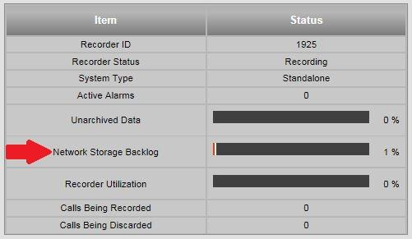

If this figure reaches 100% the recorder will stop recording and it will not start recording until the network issue has been addressed and the backlog has reduced. This will result in lost recordings.

Potential issues with the network storage are

* Loss of connection between the recorder and the NAS location
* Security permissions
* Change in username or password
* Anti-virus issues.